## Upgrading EM Architecture Framework (QRC)

## Introduction

The Upgrading EMAF QRC shows how to install the latest EMAF templates and stencils used on to ExxonMobil PCs. If EMAF templates and stencils have never been installed, perform the [Getting Started QRC](https://ishareteam2.na.xom.com/sites/at/ea/Shared%20Documents/EM%20Architecture%20Framework/Architecture%20Guidelines%20Techniques/Quick%20Reference%20Cards/Getting-Started-QRC.docx) instead.

As this is a manual install, these instructions will ensure any retired templates are removed.

## Instructions

1. From the File Explorer, navigate to your network account LocalData folder --> C:\Users\<your-id>\LocalData\My Templates directory and save to My Templates

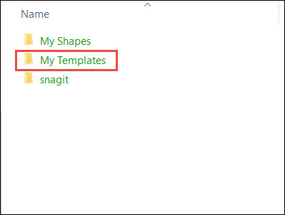

1. Select all templates by
   1. Click on any template

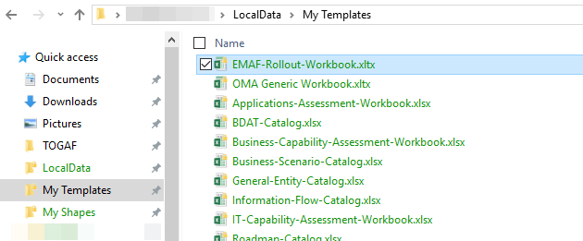

* 1. Press Ctrl+A to select all templates in folder
  2. Right mouse click any template to display pop-up menu, and click **Delete**

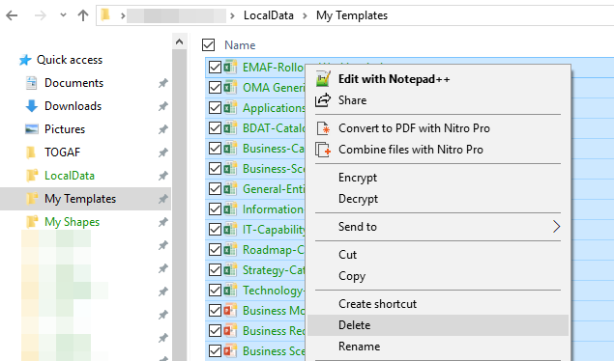

1. Execute the [Adding New Visio Templates and Shapes QRC](https://ishareteam2.na.xom.com/sites/at/ea/Shared%20Documents/EM%20Architecture%20Framework/Architecture%20Guidelines%20Techniques/Quick%20Reference%20Cards/Adding-New-Visio-Templates-and-Shapes-QRC.docx)